HAYDON ARGYLE

Brown, Star 5/2 Foaled 14/8/2012 15.2 ½ HH JEWEL FAMILY
ASHS 229706 Mare

Haydon Argyle a 7 year-old mare with good conformation, ready to step up and easy to have around, with lots of good playing siblings.

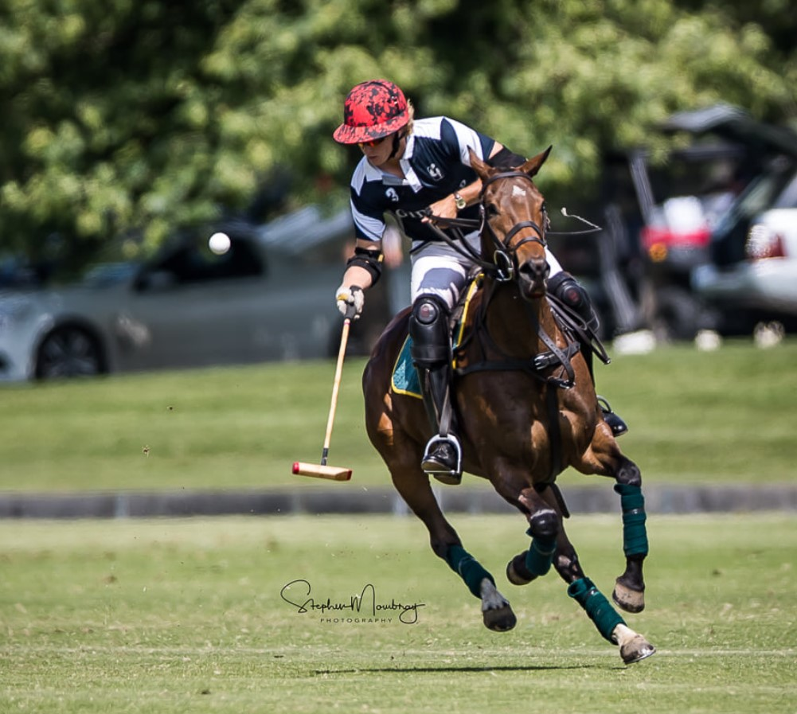

SIRE: TECHRICO | ZABEEL | SIR TRISTRAM | SIR IVOR | SIR GAYLORD
 |  |  |  | ATTICA
 |  |  | ISOLT | ROUND TABLE
 |  |  |  | ALL MY EYE
 |  | LADY GISELLE | NUREYEV | NORTHERN DANCER
 |  |  |  | SPECIAL
 |  |  | VALDERNA | VAL DE LOIR
 |  |  |  | DERNA
 | VAINDARRA | VAIN | WILKES | COURT MARTIAL
 |  |  |  | SANS TARES
 |  |  | ELATED | ORGOGLIO
 |  |  |  | RARCAMBA
 |  | HIGH QUALITY | TODMAN | STAR KINGDOM
 |  |  |  | OCEANA
 |  |  | KALDARRA | BRUEGHEL

DAM: HAYDON TOURMALINE  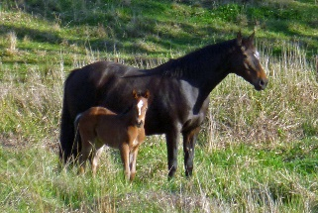 | HAYDON DRAWN | STAR SHOWER | STAR OF HEAVEN | STAR KINGDOM
 |  |  |  | MAGIC SYMBOL
 |  |  | SHOW | NOVALIS
 |  |  |  | COVENT GARDEN
 |  | PENNY DRAW | IDOMENEO | ALYCIDON
 |  |  |  | ARIETTA
 |  |  | LONG DRAW | PIPE OF PEACE
 |  |  |  | MIDWISE by MIDSTREAM
 | HAYDON EMERALD | HAYDON NEVER DOUBT | NEVER IN DOUBT - FS | NEARCO
 |  |  |  | STRANGE LADY
 |  |  | MYSTIC ROSE | SUPREME COURAGE
 |  |  |  | JANCY
 |  | HAYDON TRINKET | REDIGO | THE LIZARD
 |  |  |  | SUGAR
 |  |  | HAYDON JEWEL | BRUCE GREER
 |  |  |  | HAYDON BRACELET
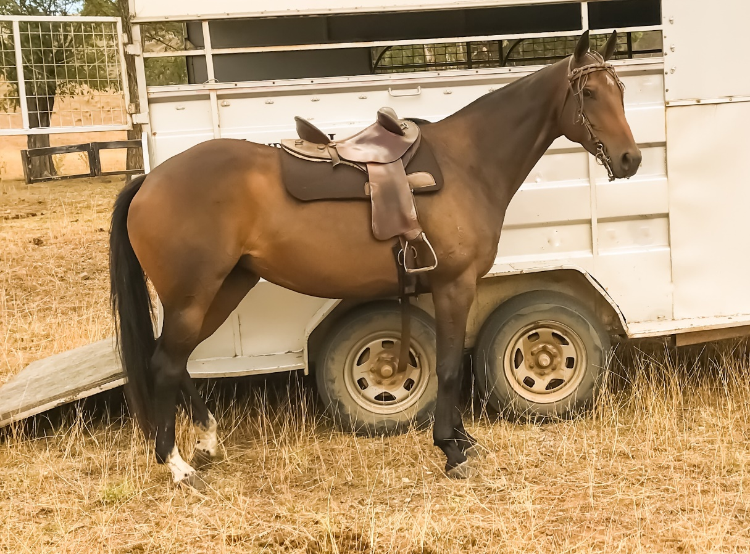

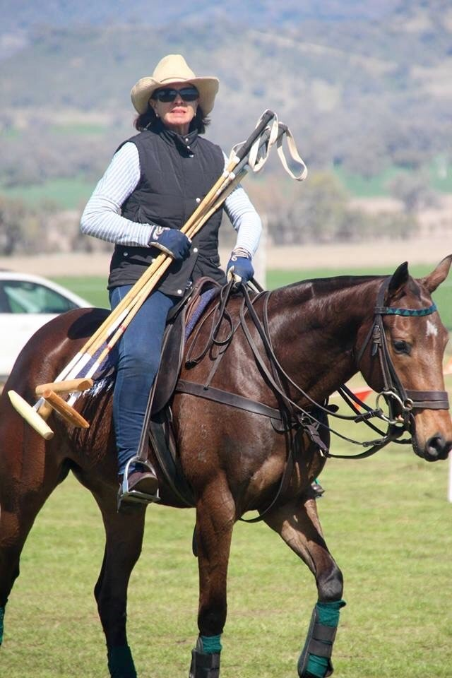

Haydon Argyle is a year younger full sister to good playing mare Haydon Crystal, here playing at Ellerston;

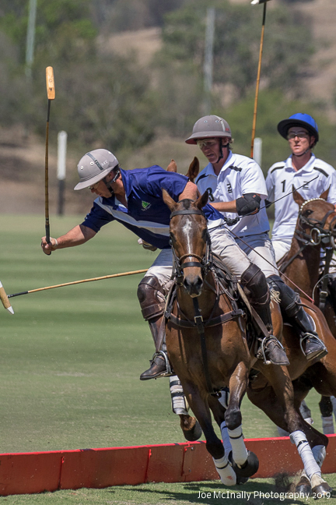

Her dam Haydon Tourmaline is a full sister to renowned international polo mare Haydon Angel Jewel, rated as Adolfo Cambiaso’s best mare outside Argentina. She has been an exceptional broodmare producing Haydon Victoriana who played the Argentine Open, Haydon Dunkirk Champion polocrosse gelding, Haydon Sky Jewel one of the top mares playing here and renowned for her pace, Haydon Pandora a top polo mare scoring 3 goals in one chukka on several occasions, promising polo mare Haydon Crystalline, Haydon Argyle a top young polo mare, as above, Haydon Jubilee who was top of her age group and joined the broodmare band, colts Haydon Oracle and Haydon Spartacus.
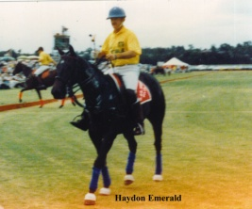
Haydon Tourmaline with Crystalline as a foal

Argyle’s grand-dam Haydon Emerald as well as being a top producing mare played right up to Test level and was an exceptional ability mare. Her 3rd dam Haydon Trinket was one of the great producing mares of the breed with 17 progeny including Haydon Emerald and her full-sister Champion polo mare Haydon Pearl and Haydon Necklace, Champion mare at the 1986 Polocrosse Nationals played by Les Fraser.

Her family traces back to Countess by Planet, Bernard Haydon’s top mare in the 1880 and has established itself as one of the best old Bloomfield families.
Haydon Emerald played by Australian Captain Jim MacGinley in the Test Match against Argentina

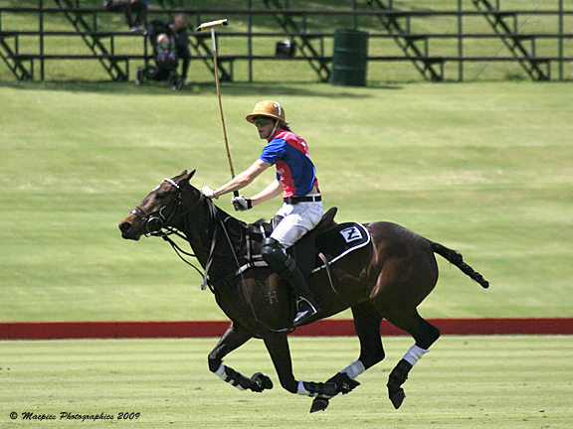

Haydon Victoriana by Victory playing at Ellerston before going onto play in the 2010 Argentine Open, is Argyle’s half-sister

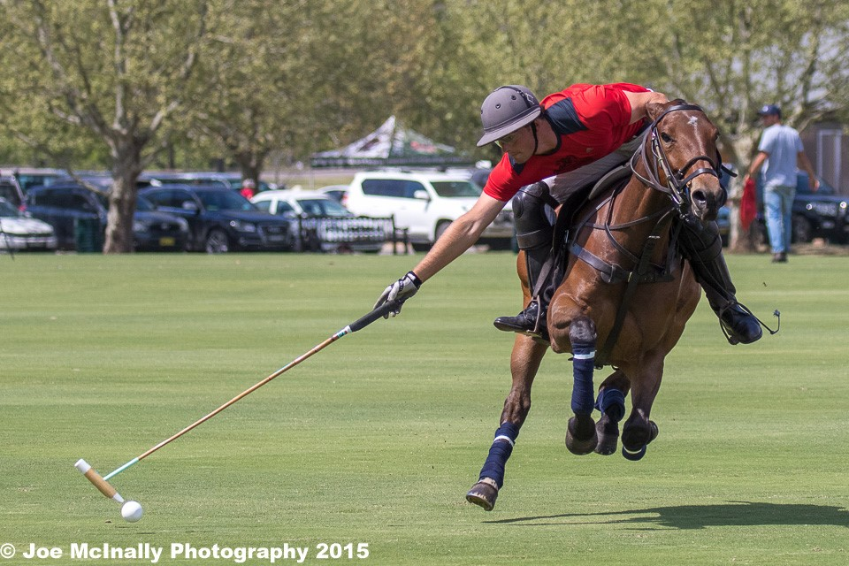

Half-sister Haydon Sky Jewel by Solar in this well known photo, wide open at Ellerston

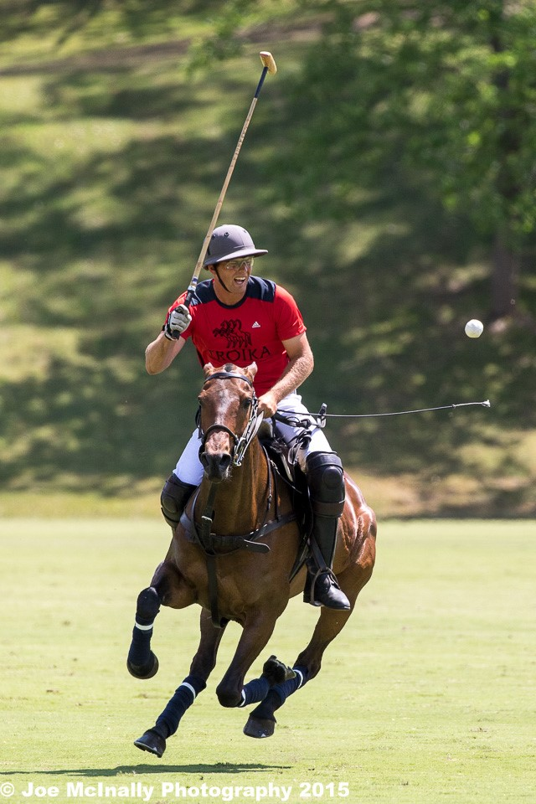

Haydon Pandora by Nightwatch is another half-sister on her way to scoring 3 goals in one chukka at Ellerston & played the final in 2016.

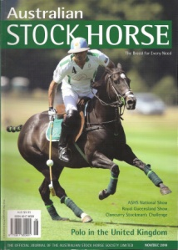

Haydon Angel Jewel played by the world's best player Adolfo Cambiaso
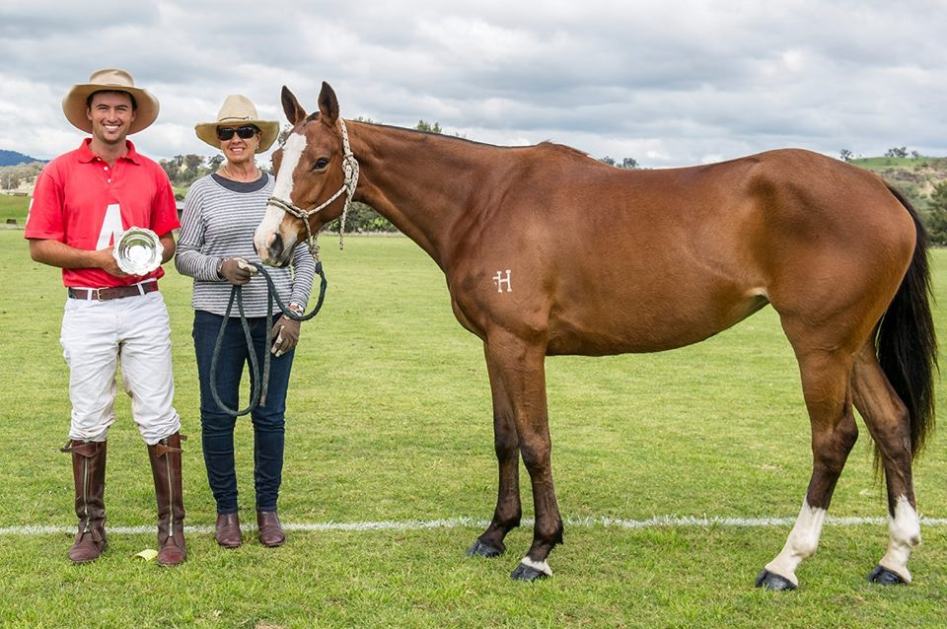
BPP Haydon Cha Cha by Victory is closely related, being out of her mother’s half-sister, playing up to Test level.

